The influence of variation in fire and grazing species relative to inherent landscape heterogeneity on the vegetation of a tallgrass prairie
McGlinn, Daniel J.^{1,2*}; Earls, Peter J.^{1,3}; & Palmer, Michael W.^{1,4}
¹Botany Department, Oklahoma State University, Stillwater, OK 74078 USA;
²Biology Department, University of North Carolina, Chapel Hill, NC 27599 USA;
³E-mail pete.earls@okstate.edu;
⁴E-mail mike.palmer@okstate.edu;
*Corresponding author; E-mail danmcglinn@gmail.com
Abstract
Question: In what ways is the plant species richness and composition of a tallgrass prairie undergoing change through time and space? How much of this change can be attributed to variation in fire and grazing species relative to inherent landscape heterogeneity?
Location: Tallgrass Prairie Preserve in Osage Co., Oklahoma, USA.
Methods: We annually resampled 100 m² square quadrats located in the grasslands of the preserve over an 11 year time period. We recorded visual cover of all vascular plant species rooted within each quadrat. We used variation partitioning and explanatory modeling within multiple regression and canonical ordination frameworks to examine patterns of species richness and composition respectively.
Results: Our results indicated that site effects, probably due to edaphic differences, explained the majority of variation in richness and composition. Year effects, related to seasonal precipitation, were more strongly correlated with variation in richness than composition. Interannual variation in fire and grazing was relatively unimportant relative to inherent site and year drivers with respect to both richness and composition; however, the effects of fire and grazing variables were statistically significant and interpretable, and bison management was positively correlated with plant richness.
Conclusions: The strength of inherent landscape heterogeneity on the plant community suggests that fine-tuning the application of fire and grazing is not critical for maintaining this community as long as woody plant encroachment is kept in check. Our study’s observational approach complements other work documenting the influence of fire and grazing with strictly controlled treatments.
Nomenclature: USDA Plants database (2009)

Keywords: bison, Flint Hills, grassland, natural variability concept, Oklahoma, restoration, vascular plants, and vegetation monitoring

Introduction
Natural variability concepts of land management, which promote spatial and temporal variability, are increasingly used in restoration ecology (Palmer et al. 1997). Underlying these concepts are two premises: 1) historical conditions and processes can provide guidance for management, and 2) spatial and temporal variability generated by disturbance are vital components of nearly all ecosystems (Landres et al. 1999). Proponents of natural variability concepts believe that managing for historical conditions will benefit species that have evolved in that system and will therefore minimize local extinctions of native taxa (Swanson et al. 1994, Cissel et al. 1999). Additionally, spatial and temporal variability in environmental heterogeneity is thought to maintain biological diversity (MacArthur 1965, Petraitis et al. 1989). Although these concepts are grounded in ecological theory, as Palmer et al. (1997) note, the importance of managing for natural variability is rarely examined experimentally.
The application of natural variability concepts is relevant to the conservation and restoration of the North American tallgrass prairie ecosystem. In this ecosystem, fire and grazing were important components of the pre-Columbian North American disturbance regime (Anderson 1990) and still are today (Daubenmire 1968, Abrams et al. 1986, Collins 1992). Although historically the region was grazed by bison (Bos bison L.) and was burned in a variety of seasons, presently much of the remaining tallgrass prairie ecosystem is managed for cattle with annual spring burns (Fuhlendorf and Engle 2001). The purpose of annual spring burning is to maximize yields of palatable C4-grasses (Towne and Owensby 1984). Howe (1994) also noted that many restoration efforts on prairie remnants promote production of C4 grasses with spring season burning and a lack of grazing. These management practices may be a threat to the ecosystem’s biodiversity by only benefiting one competitively superior plant functional group and by homogenizing an entire region’s disturbance regime (Howe 1994, Fuhlendorf and Engle 2001, Nekola and White 2002).
In an effort to restore natural variability to grazing systems, Fuhlendorf and Engle (2001, 2004) suggested the interaction between fire and grazing could be used in a more variable manner in space and time to create a shifting mosaic in contrast to the traditional homogenous application of these management tools. They argued that a mosaic of burned and unburned patches more closely approximates the historical variability that would have existed on the landscape and will result in higher biodiversity than traditional homogenous management practices (annual spring burning). This hypothesis is guiding the management of the Tallgrass Prairie Preserve (TGPP), one of the largest tallgrass prairie preserves (Hamilton 1996, 2007).
The scale of the TGPP (15,700 ha) coupled with the spatially and temporally varying application of fire, the usage of both native and exotic grazers, and intact native vegetation provides both important opportunities and challenges for experimentally evaluating aspects of the natural variability hypothesis. Specifically the TGPP is an ideal setting for conducting a long-term observational study on the relative importance of variation in grazing and fire in a tallgrass prairie ecosystem that is presumably in somewhat of a more pre-Columbian (‘natural’) state. This opportunity is valuable because the majority of our knowledge on tallgrass prairie ecology either originates from relatively small scale experiments (e.g., Hulbert 1988) or from strictly controlled watershed treatments (e.g., Konza prairie LTER studies).
Controlled studies are extremely valuable in elucidating ecological mechanisms that underlie a system, but they are less useful in providing the ability to examine multiple driving factors of community change within a broader ecological context. This can be better achieved by an observational study if properly designed (Hobbs et al. 2007, Weiher 2007) Examining more than two or three treatments at several levels requires more replication than is typically feasible in long-term ecological research, however, the effect of several factors can be statistically separated in an observational study with relatively few replicates. Furthermore, in many conservation contexts certain landscape scale experimental manipulations may be unethical or conflict with overall management goals (e.g., permanent unburned or ungrazed treatments at the TGPP), and therefore an observational study is the only method of examining the response of the biota to management decisions (Farnsworth and Rosovsky 1993, Marsh and Kenchington 2004).
The purpose of this study was to quantify the importance of variability in prescribed burning and grazing (i.e., the difference between cattle and bison grazers) on changes of plant species richness and composition in space and time at the TGPP relative to changes due to in situ site and year variation. Our goal was not to directly test whether or not variation in fire and grazing are effective tools for meeting conservation targets, but rather to examine the relative influence that variation in these variables has on variation in the plant community. Differences due to variation in fire and grazing within sites are likely to be strongly confounded by year-to-year variation in climate (Anderson 1982, Gibson and Hulbert 1987, Adler and Levine 2007) and between sites by variation in soil (Critchley et al. 2002) and topography (Abrams and Hulbert 1987, Briggs and Knapp 1995). However, these confounding differences can be statistically controlled for and separated from one another using variation partitioning (Borcard et al. 1992, Økland and Eilertsen 1994). Variation partitioning provides estimates of the independent and shared importance of several groups of variables relative to one another.
Using a mixture of explanatory modeling and ordination techniques, we addressed three related questions. Is there directional change in species richness and species composition through time? What are the most important environmental variables for explaining plant richness and composition? If site and year effects are controlled for, does spatiotemporal variation in fire and grazing correlate significantly with richness or composition and, if so, in what way?

Methods

Study Site
The TGPP is a 15,700 ha nature preserve located between 36.73° and 36.90° N latitude, and 96.32° and 96.49° W longitude, in Osage County, Oklahoma and owned by The Nature Conservancy (TNC). Over the course of the 11 year study period (1998-2008), total annual rainfall varied from 490 to 1250 mm. The preserve is situated at the southern extent of the Flint Hills region. The elevation of the preserve ranges from 253 to 366 m, and the underlying bedrock of the region is characterized by soils deriving from Permian sediment (Oviatt 1998). Due to long-term erosion, the surface layers of soil are thin and young; limestone and sandstone are frequently exposed at the surface, sometimes within close proximity of each other. Because of this rockiness the Flint Hills region, including the Tallgrass Prairie Preserve, has remained unplowed and has been instead utilized primarily as rangeland for cattle. Prior to the acquisition of the preserve by TNC in 1989, the majority of the site was managed for cow-calf and yearling cattle production with a 4- to 5-year rotation of prescribed burning and aerial application of broadleaf herbicides (1950-1989) (Hamilton 2007).
Approximately 90 % of the TGPP consists of grasslands. The majority of the grasslands are composed of tallgrass prairie habitats dominated by Andropogon gerardii, Sorghastrum nutans, Sporobolus compositus, Panicum virgatum, and Schizachyrium scoparium. Shortgrass prairie habitat occurs to a lesser extent on more xeric sites and is dominated by Bouteloua spp. Despite the application of herbicide earlier in the 20th century, the flora of the preserve appears relatively intact with a total of 763 species of vascular plants (to date) of which 12.1% are exotic (Palmer 2007).

Management Plan
The management plan at the TGPP encompasses a wide range of spatial and temporal variation in the application of prescribed fire and cattle or bison grazing (Hamilton 1996, 2007). In 1993, 300 bison were introduced year-round onto a 1,960 ha portion of the preserve. As the bison herd increased in size, the area allotted to the herd was increased eight times to an area of 8,517 ha by 2007 (Fig. 1, 54% of preserve area). Initial bison stocking rates were increased in 1999 to 2.1 animal-unit months ha⁻¹ (see Hamilton 2007 for additional details). Within the bison unit, animals were allowed to range freely and their movement was not obstructed by internal fences. Watersheds within the bison unit were considered randomly for burning only if they met the minimum fuel criteria of 900 kg ha⁻¹ of fine fuels. Within a given year, the season of burn of the bison unit was split as follows: 40 % dormant spring (March - April), 20 % late growing season (August - September), and 40 % dormant winter (October - December). The remainder of the preserve was seasonally grazed by cattle and typically burned more frequently in the dormant spring season, but some of the cattle pastures were utilized for smaller scale (2,350 ha) patch-burn experiments in which only one-third of a given management unit was burned annually (Hamilton 2007). Stocking within the cattle pastures included both intensive-early stocking and season-long stocking, which contrasted with the year-round stocking in the bison unit.

Data collection
Management units were spatially aggregated and temporally variable. We therefore opted to annually re-sample a semi-random, spatially stratified set of twenty square 100 m² plots located at the intersections of the 1-km UTM grid (Fig. 1.). The only criteria that we imposed on the selection of the plots were that they had no standing water and less than 20 % cover of woody plants or exposed rock. A semi-unbiased spatial stratification of samples is an ideal sampling method for ensuring that samples are representative of the broader variation in grassland communities across the preserve (Palmer 1995). We opted to annually resample the sites to observe the vegetation at a given site in multiple management states (e.g., one year post burn, bison vs. cattle grazed), and to provide information on inherent year-to-year variation. We resampled the plots every June from 1998 to 2008 and recorded the percent cover of all vascular plant species at the 100 m² scale.
Each year we combined four 15 cm soil cores collected at each corner of the quadrat and sent these to Brookside Labs (New Knoxville, Ohio) to be analyzed for soil cations, pH, and other variables. We recorded topographic data on slope and aspect in the field. For analyses, aspect was converted to an index of northness [northness = cos(aspect)] (Roberts 1986). We did not consider a corresponding index of eastness as exploratory results indicated it was unimportant (not shown).
Climatic variation was quantified with total monthly precipitation data from the Oklahoma Mesonet Foraker site (36.841° N, -96.428° W; elevation: 330 m; Fig. 1), which is located on the preserve (McPherson et al. 2007). We calculated total precipitation for three arbitrarily defined season variables (four months each): June through September (summer), October through January (winter), and February through May (spring).
To examine variation in fire and grazing we derived three variables: years of bison grazing, years since burn, and number of burns in the past five years, from a GIS database that we developed based on TNC’s recorded burn and grazing history. We recognize that the number of burns in the past five years is negatively correlated with years since last burn (see Appendix A) and reflects somewhat of an arbitrary cutoff point (five years), but we chose to include this variable in our models despite these shortcomings because we wished to quantify the short-term burn history of a site. If a site is burned frequently, then the “years since burn” variable will not convey any information on the history of the site beyond the last burn. We chose not to include season of burn as an explanatory variable because 83% (67 out of 80) of the prescribed fire events recorded on our study sites took place during the dormant season.
It is important to note two aspects of the fire and grazing variables: 1) the application of fire and grazing was heterogeneous in space and time (i.e., there were no fixed treatments), and 2) the variables time since fire and number of burns in the past five years are inherently temporally variable (i.e., even if a site had experienced a fixed fire-return interval, these variables would display variation through time).
We grouped species into five functional groups to aid in the ecological interpretation of patterns of species richness and composition we observed. The functional groups were forbs, legumes, C3 grasses, C4 grasses, and shrubs.

Data analysis
Our goal when modeling richness and species composition was to develop explanatory models and not predictive models, sensu Mac Nally (2000). Therefore, we were primarily concerned with comparing the explanatory strength of variables that were chosen a priori rather than developing a single most accurate or necessarily most parsimonious model. We coded site and years as dummy variables to quantify site and year effects relative to fire and grazing variables. We then performed a post-hoc examination of the specific environmental variables (described in Data collection) that we believed may explain the site and year effects.
Given the observational nature of this study, many of our environmental variables (e.g., soil cations, total spring rain) were strongly collinear and likely act as proxy variables. Therefore, to increase the clarity of our results, we only examined a small number of environmental variables. We selected calcium as the soil variable to examine because previous published analyses that used portions of our dataset indicated that this variable was strongly correlated with richness and acted as a proxy for limestone (rather than sandstone) derived soils (Palmer et al. 2003, Brokaw 2004). We included field measurements of slope and aspect in the analysis which we expect to reflect variation in the degree of moisture and solar exposure. Aspect was converted to an index of northness [northness = cos(aspect)] (Roberts 1986). We did not consider a corresponding index of eastness as exploratory results indicated it was unimportant (not shown). We examined seasonal totals of rainfall because exploratory analyses indicated it greatly out performed total rainfall (not shown).
We used ordinary least squares (OLS) and generalized least squares (GLS) to dissect relationships between species richness and our various explanatory variables. OLS is ideal for providing interpretable estimates of variance explained; however, exploratory analyses revealed the presence of year-to-year temporal autorcorrelation in richness which violates one of OLS’s assumptions. We used first-order autoregressive GLS models to correct for the temporal autocorrelation. First-order autoregressive models are one of the simplest models of temporal autocorrelation, and they attempt to correct for short-term autocorrelation between our samples within a site (Pinheiro et al. 2008, p. 228-229). The GLS models were fit with a restricted maximum likelihood algorithm, which is the preferred method for generating unbiased estimates of variance in models that have a relatively large number of parameters (Diggle et al. 1994). The R package nlme version 3.1-90 was used to carry out all GLS model fitting and diagnostics (Pinheiro et al. 2008).
We used variation partitioning (or commonality analysis) to estimate the unique and shared fractions of explained variation in three groups of variables (or factors), sites, years, and fire and grazing on richness (Legendre and Legendre 1998, Peres-Neto et al. 2006). Sites and years were coded as dummy variables and the fire and grazing group was composed of the three fire and grazing variables described above. The independent component of variation attributable to fire and grazing should be interpreted as variation within-sites which was independent of specific years and was associated with temporal changes in the fire and grazing variables that occurred over the study period. For example, over the course of the study, seven of the sites changed from cattle grazed to bison grazed. The analysis associated variation in these sites after their change in grazer that was independent of a specific year effect with the variable years of bison grazing. In contrast, if a site remained in the cattle unit for the duration of the study then the variable, years of bison grazing, would not have been associated with explained temporal variance at that particular site.
We carried out partitioning with OLS as well as with GLS multiple regressions. For each fraction of the OLS analysis, we report both the coefficient of determination and its adjustment for number of variables, 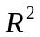 and 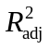 respectively. For the GLS fractions we calculated a generalized formulation of the coefficient of determination, 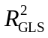, that is appropriate for GLS models (Nagelkerke 1991). We used approximate, conditional (type III) F-tests to assess if a group or variable explained a significant amount of variance in richness.
In all analyses we treated species richness as a continuous variable with normally distributed error. We recognized that in some modeling contexts it is more appropriate to consider richness as a Poisson distributed variable (Candy 1997, Palmer and Hussain 1997). However, because the normal distribution provides a good approximation of a Poisson random variable when the mean is larger than approximately 20; we feel that our usage of normal errors (instead of Poisson) is justified given that richness was never below 48 in our samples. We also recognize that some authors consider richness to only be one facet of grassland biodiversity and that other diversity indices can yield more insight into the ecology of the system (Wilsey et al. 2005, Chalcraft et al. 2009). However, in this study richness was so strongly correlated with all of the indices examined in Wilsey et al. (2005) that additional analyses on various diversity indices would have yielded little additional insight (see Appendix B).
We used both indirect and direct gradient analyses to examine species composition. Prior to all ordinations, we square-root transformed all species cover data to decrease the influence of the most abundant species on the analysis, and we down-weighted rare species. Detrended Correspondence Analysis (DCA; Hill and Gauch 1980) was used to visually inspect directional change in the plant composition through time and to estimate the amount of variation composition displayed across a hypothetical environmental gradient. We used non-metric multidimensional scaling (NMS), another indirect ordination technique, to confirm the general conclusions of the DCA.
For the analysis of species composition we also carried out variation partitioning but with partial canonical correspondence analysis (pCCA) (Borcard et al. 1992, Økland 1999). The groups used in the variation partitioning were as defined above for richness. We calculated Peres-Neto et al.’s (2006) formulation of the adjusted fraction of variation explained in CCA using a permutation approach (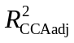). To our knowledge, correlational models for the residuals have not been theoretically developed within the direct ordination context and therefore these methods were not applied in our analysis of species composition. However, when testing the importance of dependent variables that accounted for the within-site variability in species composition, we conducted a toroidal shift Monte Carlo test (Legendre 1993, ter Braak and Šmilauer 2002b). This method of permutation maintains the observed order of the samples within a site while nullifying the temporal relationship of samples between sites. When the constraining variable was site specific, we carried out permutations that randomly shuffled samples only within their year of occurrence to conform with our assumption of spatial independence between sites but not years. All randomization tests were conducted with 999 iterations to determine significance of all canonical axes for all partial CCA analyses under the reduced model (Legendre and Legendre 1998, p308). As in the analysis on richness, we constructed models to examine the importance of specific explanatory variables with estimates of variation explained and conditional F-tests. We performed multivariate analyses with CANOCO version 4.5 (ter Braak and Šmilauer 2002a) and the R package vegan version 1.15-1 (Oksanen et al. 2008, R Development Core Team 2008). A total of 25 tests were performed, and to minimize our Type I error rate we used the Bonferroni alpha level of 0.002 (= 0.05/25) to judge significance.

Results

Variance in species richness
The average species richness over the 11 year study was 76.24 (± 0.86). The between-year variance (σ = 9.13) in richness was approximately equal to the between-site variance (σ = 8.93). There were not strong directional changes in total richness (not shown) or in the five functional groups through time (Fig. 2). Forbs were more species-rich than all other functional groups. Variation partitioning of the unbiased OLS estimate of variance explained (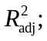Table 1), indicated that between-site differences accounted for the majority of variance in richness (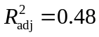), followed by year-to-year differences (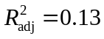). However, after within-site temporal autocorrelation was considered (using a first-order auto-regressive term), the strength of site identity relative to year identity was diminished substantially according to Nagelkerke’s (1991) generalized definition of the coefficient of determination. In both OLS and GLS based variation partitioning, the fire and grazing class of variables accounted for a much smaller percentage of explained variance in richness (2-4 %), but still contributed a significant amount of explained variation (Table 2). There was a large shared fraction of variation (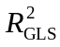= 0.25) between site and year that was only apparent after correcting for the inherent temporal autocorrelation. The shared components of variation between fire and grazing and site and between fire and grazing and year were comparable to the influence of fire and grazing alone.
The most important variable for explaining site-to-site differences in richness was log Ca, which was negatively correlated with richness (standardized coefficient, β = -0.42) (Table 2). Topography did not seem to have a strong influence on richness as neither slope nor northness explained much variation in richness.
Temporal variation in richness within the sites was attributable to both climate and fire and grazing variables. The most important seasonal rainfall variable was summer rain, which was negatively correlated with richness (β = -0.19); winter rain and spring rain appeared equally important and both were positively associated with richness (β = 0.15 and 0.14, respectively). The single most important fire and grazing variable was years of bison, which was positively associated with richness (β = 0.46). Both years since burn and number of burns in the past five years were negatively associated with richness but neither variable was found to explain significantly more variation in richness than due to chance at the Bonferroni corrected alpha level of 0.002 (Table 2).

Variance in species composition
The DCA scatterplot indicated that change in species composition through time was not directional (Fig. 3). Furthermore, sites remained relatively separate from one another in ordination space, which indicates that variation in species composition was greater between sites than within sites. There was not a strong difference in sample scores between sites that were bison- versus cattle-grazed along the first through fourth DCA axes (third and forth axes not shown). Furthermore, when samples switched from cattle to bison, their trajectory through time did not change substantially. The results of the NMDS (not shown) corroborated these qualitative results.
Variation partitioning based upon CCA indicated that site effects explained the majority of the variation in species composition (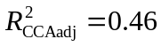, Fig. 4). Year and fire and grazing effects on species composition were negligible after adjustment, but both were still found to be significant in randomization tests at the 0.05 level (Table 3). There was a relatively large shared site and fire and grazing fraction (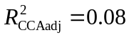) of explained variation. The pCCAs that considered site specific explanatory variables after factoring out year and fire and grazing effects indicated that log Ca was the most important site specific variable (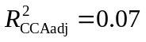; Table 3).
Although fire and grazing explained only a very small proportion of the variation in species composition, we feel that for applied purposes it is still worth examining the fire and grazing effects on particular species using a pCCA biplot (Fig. 5). The pCCA biplot displays only the 90 most abundant species (although all 307 species were included in the analysis) with respect to the three fire and grazing variables after factoring out year and site effects as dummy variables. It appeared that both C3 and C4 grasses (open and filled black circles on biplot respectively) appeared to decrease in cover with increased years of bison grazing. Lespedeza cuneata (sericea lespedeza), an invasive species, was positively correlated with years of bison grazing. However, this species is a target for herbicide application by the TNC so care must be taken in interpretation of this result. Annual and ruderal species, such as Chamaesyce nutans (eye bane), Plantago virginica (Virginia plantain), Ambrosia artemisiifolia (annual ragweed), and Andropogon virginicus (broomsedge bluestem), all were positively associated with the number of burns in the past five years.

Discussion
The purpose of our study was to examine the influence of variation in fire and grazing on plant richness and composition relative to intersite and interyear variability. Our results suggest that the grasslands of the TGPP are not undergoing strong directional changes in richness or composition through time (i.e. they do not appear to be on a clear trajectory). Rather, sites appear to maintain their differences over time and respond somewhat idiosyncratically to fire and grazing effects. This is not to say that the effects of variation in fire and grazing on richness and composition independent of site and year were irrelevant and uninterpretable, but simply that fire and grazing were relatively unimportant relative to inherent sources of landscape heterogeneity.

Role and drivers of site-to-site variation
The bulk of the variation in richness and composition was due to differences between sites, which we believe primarily reflects belowground differences between our samples. We found that calcium explained the predominant amount of site-to-site variability in both richness and composition (Table 2). We interpret calcium’s importance to be due to its role as a proxy variable for many other soil properties which are generally indicative of limestone derived soils (Palmer et al. 2003, Brokaw 2004). Using the same 20 sites analyzed in this study (only for the year 2002), Brokaw (2004) found that out of a set of 12 different soil nutrients and total carbon that the two most important variables for explaining plant composition (using pCCA) were total carbon and residual phosphorus. These two variables were strongly positively correlated with the majority of soil nutrients and calcium which Brokaw (2004) interpreted as general indicators of limestone parent materials. These findings suggest that the important role that calcium played in our study does not necessary contradict the body of work that suggests that below ground nutrients are the predominant drivers (not cations) of plant richness and composition in tallgrass prairie ecosystems (Turner et al. 1997, Burke et al. 1998, Baer et al. 2003, 2004).
Why was the relationship between calcium and richness negative? The positive relationship between calcium and soil nutrients (that Brokaw [2004] found in our samples) suggests one possible explanation. If soils high in calcium are the productive, nutrient rich sites, then plant species at these sites may experience stronger competitive exclusion and therefore have lower richness (Grime 1973, Tilman 1982). Pärtel’s (2002) species pool hypothesis offers an alternative hypothesis for the negative correlation between richness and calcium (Palmer et al. 2003). The species pool hypothesis postulates that negative correlations between richness and pH (or calcium given their tight correlation) will occur in regions in which habitats high in pH were evolutionarily scarce. Palmer et al. (2003) found that the data from the Tallgrass Prairie Preserve (including this study’s sites as well as many others) appeared to support Pärtel’s hypothesis in the grasslands but not in the woodlands.

Role and drivers of year-to-year variation
Year-to-year variation was a better explanatory variable of richness than composition. This indicates that changes in year-to-year composition were primarily idiosyncratic. Relative to site and fire and grazing groups, the year group explained almost equal amounts of variation in richness as site effects (21% compared to 25%) with 9 fewer parameters. With respect to species composition, year effects were more comparable with the small influence of fire and grazing (both were < 1%).
Climatic variability is the most obvious driver of year-to-year variation (that is independent of fire and grazing effects). In the tallgrass prairie plant community water is typically viewed as an important limiting resource, and it is generally positively associated with richness in grasslands (Cornwell and Grubb 2003, Adler and Levine 2007, Wilson 2007). In our study, richness was positively correlated with the winter and spring seasonal precipitation variables, but negatively correlated with the summer precipitation variable. Although all the season variables explained a significant amount of variance in richness, it appeared that the independent negative effect of the summer variable was largest with respect to richness (Table 2). Following Adler and Levine (2007), increased precipitation may act on richness directly by making the environment more benign and thus allowing more species to coexist. However, if this was generally true, then it is difficult to explain the strong negative correlation observed for summer rainfall. An alternative season specific hypothesis that may explain the negative relationship with summer rainfall is that increased precipitation in the summer previous to sampling yields higher aboveground cover of C4 grasses. High yields of aboveground biomass could act to both inhibit germination of annuals and biennials later at the beginning of the next growing season as well as increase asymmetric light competition due to increased litter (Grace 2001). The positive influence of spring and winter rains may also be explained by the critical role that rainfall plays in stimulating germination in the annuals and biennials during the dormant seasons. In this sense precipitation is viewed as a non-resource variable that indirectly influences richness by increasing aboveground primary productivity the summer prior to sampling and by influencing germination of species-rich plant groups (Grace 2001, Adler and Levine 2007).

Fire and grazing effects
Despite the occurrence of 80 recorded fire events across our twenty sites and the usage of different grazers, our results indicated that variation in these management tools were relatively minor in comparison to inherent site and year heterogeneity. This result is in conflict with the dominant paradigm of tallgrass prairie ecology, which asserts that fire and grazing are the dominant drivers of diversity and composition in tallgrass prairie vegetation (Collins 1987, Gibson and Hulbert 1987, Anderson 1990). Although the importance of site and year effects is not a novel insight in this system, they are rarely observed to dominate the influence of fire and grazing so strongly. There are several reasons that likely led to this result. Our samples cover a larger spatial extent than the majority of other tallgrass prairie studies, given the large size of the TGPP. Additionally, due to the observational nature of our study, we did not compare our samples to control sites that received no burning and/or grazing, although some of our sites went as long as 10 years without fire. And lastly, by utilizing site and year dummy variables, we provided a conservative (but we believe more honest) estimate of the independent influence of spatiotemporal variation in fire and grazing.
Although the fire and grazing group explained little variation overall, years of bison grazing had a strong positive relationship with richness (Table 2). This suggests that “bison management” is having a positive influence on richness at the TGPP. We stress bison management rather than the influence of bison directly because the average fire-return interval was generally longer and the season of burn was more variable in the bison units when compared with the cattle units (Hamilton 2007). Also the bison units were grazed year round, while the cattle units were only seasonally grazed. Therefore, we are fairly confident bison management is having a positive effect on richness, but we are less confident that this is due actually to the presence of bison in comparison to cattle.
One explanation for the positive correlation between years of bison and richness may be related to the dietary differences between cattle and bison. Bison are thought to selectively forage on graminoids rather than forbs (in contrast to cattle which behave more as generalists) (Coppedge et al. 1998b, Knapp et al. 1999). This dietary behavior may release forbs from competitive exclusion due to the dominant C4 grasses. Years of bison grazing was negatively correlated with the cover of the majority of C3 and C4 species (Fig. 5). The increase in richness and decrease in graminoid cover in the bison managed sites lend modest support to the hypothesis that bison may increase richness of tallgrass prairie by decreasing the cover of graminoids relative to sites that were grazed seasonally by cattle.
Towne et al. (2005) undertook a more controlled approach to investigating the effects of bison and cattle grazing on plant richness and composition at the Konza tallgrass prairie over a 10 year period in annually burned pastures. They also found that overall the differences between bison and cattle were slight but that bison grazed patches had a higher cover of some forb species and gained forb species at a more rapid rate through time. They concluded the differential responses of vegetation to bison or cattle grazing may be predominately due to differences in management of these grazers rather than inherent differences in their biology. A similar effect may be taking place at our study site as well.
Years since last burn was most strongly correlated with changes in species composition (Fig. 5), but the other two fire and grazing variables explained comparable amounts of variation (Table 3). Other studies have noted the strong positive relationship between the cover of legumes and C4 grasses with frequency of dormant season burning (Hulbert 1988, Towne and Knapp 1996, Coppedge et al. 1998a, Peterson et al. 2007), although 84% of the burns in our samples occurred during the dormant season, there was not a clear relationship between fire frequency and either of these functional groups (Fig. 5). We found anecdotal evidence that ruderal species were positively associated with the number of burns in the past five years (Fig. 5), which is to be expected given that these samples were likely to have higher grazing pressure due to their more nutritious regrowth (Coppedge and Shaw 1998, Fuhlendorf and Engle 2001).

Management implications
Our results suggest that management-influenced variables can cause significant changes in plant species richness and composition; however, the exact details of the management plan for tallgrass prairie plant communities may be of less importance given the large sources of inherent landscape heterogeneity we observed. This may be welcome news for land managers because it suggests that intact tallgrass prairie plant communities may be relatively insensitive to the exact management prescription, as long as some combination of fire and grazing is present on the landscape. Although our study did not examine long-term unburned and/or ungrazed sites, it is worth noting that tallgrass prairie landscapes managed in this way are likely to experience increased woody encroachment (e.g., Briggs et al. 2002).
At our study site, TNC is utilizing a variable application of prescribed fire to meet several conservation goals. One goal is to maintain or increase the biological diversity of the plant community (Hamilton 2007). The non-directional changes in species composition and relatively weak increase in richness we observed over the 11-year period suggest that the management decisions are at the very least not detrimental to the plant community. TNC is also attempting to manage for wildlife habitat and diversity. Structural heterogeneity in the vegetation, attributed to the variable application of fire, resulted in the development of suitable habitat for a wider breadth of grassland bird species at the TGPP (Fuhlendorf et al. 2006, Coppedge et al. 2008). These results in conjunction with our findings suggest that the management decisions at the preserve are contributing to important conservation goals, even if their effects on plant richness and composition are slight.

The importance of observational studies
Even without control treatments, observational studies can provide vital information about the ecology of a system (Underwood et al. 2000, Legg and Nagy 2006, MacNeil 2008). To examine long-term trends at our study site, it was more appropriate to conduct an observational study (rather than a manipulative one) given our interest in the role of inherent heterogeneity as well as spatiotemporal variation in fire and grazing. Our study demonstrates that long-term plots may be a potentially valuable source of information despite a lack of clearly defined treatments, if they are placed objectively (Palmer 1993). This is not to say that experimental studies are not necessary for uncovering driving mechanisms, but rather that it is often valuable to complement them with observational studies such that the context of their results can be better interpreted. Furthermore, at our study site and in many other conservation contexts, large-scale manipulative studies are often logistically unfeasible or in direct conflict with conservation goals and management priorities (Farnsworth and Rosovsky 1993, Marsh and Kenchington 2004).

Conclusions
The influence of spatiotemporal variation in fire and grazing on plant richness and composition was relatively minor relative to inherent variation between sites and years. Nevertheless, variation in fire and grazing had significant and interpretable effects, and we detected a significant positive correlation between bison management and plant richness. Given the overriding influence of inherent landscape heterogeneity on the plant community, the exact details of a management plan that incorporates the variable application of fire and grazing may not be of critical importance to maintaining tallgrass prairie plant communities.

Acknowledgments
DJM received funding from the U.S. Environmental Protection Agency (EPA) under the Greater Research Opportunities (GRO) Graduate Program. The U.S. EPA has not officially endorsed this publication, and the views expressed herein may not reflect the views of the Agency. Additionally we thank Bob Hamilton, members of Laboratory for Innovative Biodiversity and Analysis, and the Osage Nation for assistance with field work. NSF Grant Number EPS-0447262, The Oklahoma State University College of Arts and Science, The Oklahoma Nature Conservancy, The Spatial and Environmental Information Clearinghouse, The Philecology Trust, The Swiss Federal Institute for Forest, Snow and Landscape Research, and the Oklahoma Water Resources Research Institute for assistance at various stages of research at the Tallgrass Prairie Preserve.

Literature Cited
Abrams, M. D. and L. C. Hulbert. 1987. Effect of topographic position and fire on species composition in tallgrass prairie in northeast Kansas. American Midland Naturalist 117:442-445.
Abrams, M. D., A. K. Knapp, and L. C. Hulbert. 1986. A ten-year record of aboveground biomass in a Kansas tallgrass prairie: effects of fire and topographic position. American Journal of Botany 73:1509-1515.
Adler, P. B. and J. M. Levine. 2007. Contrasting relationships between precipitation and species richness in space and time. Oikos 116:221-232.
Anderson, E. 1990. The historic role of fire in North American grassland.in S. L. Collins and L. L. Wallace, editors. Fire in North American tallgrass prairies. University of Oklahoma Press, Norman, Oklahoma.
Anderson, R. C. 1982. An evolutionary model summarizing the roles of fire, climate, and grazing animals in the origin and maintenance of grasslands: an end paper. Pages 297-308 in J. R. Estes, R. J. Tyrl, and J. N. Brunken, editors. Grasses and grasslands: systematics and ecology. University of Oklahoma Press, Norman, Oklahoma, USA.
Baer, S. G., J. M. Blair, S. L. Collins, and A. K. Knapp. 2003. Soil resources regulate productivity and diversity in newly established tallgrass prairie. Ecology 84:724-735.
Baer, S. G., J. M. Blair, S. L. Collins, and A. K. Knapp. 2004. Plant community responses to resource availability and heterogeneity during restoration. Oecologia 139:617-629.
Borcard, D., P. Legendre, and P. Drapeau. 1992. Partialling out the spatial component of ecological variation. Ecology 73:1045-1055.
Briggs, J. M., G. A. Hoch, and L. C. Johnson. 2002. Assessing the rate, mechanisms, and consequences of the conversion of tallgrass prairie to Juniperus virginiana forest. Ecosystems 5:578-586.
Briggs, J. M. and A. K. Knapp. 1995. Interannual variability in primary production in tallgrass prairie - climate, soil-moisture, topographic position, and fire as determinants of aboveground biomass. American Journal of Botany 82:1024.
Brokaw, J. M. 2004. Comparing explanatory variables in the analysis of species composition of a tallgrass prairie. Proceedings of the Oklahoma Academy of Science 84:33-40.
Burke, I. C., W. K. Lauenroth, M. A. Vinton, P. B. Hook, R. H. Kelly, H. E. Epstein, M. R. Aguiar, M. D. Robles, M. O. Aguilera, K. L. Murphy, and R. A. Gill. 1998. Plant-soil interactions in temperate grasslands. Biogeochemistry 42:121-143.
Candy, S. G. 1997. Poisson vs normal-errors regression in Mac Nally (1996). Austral Ecology 22:233-235.
Chalcraft, D. R., B. J. Wilsey, C. Bowles, and M. R. Willig. 2009. The relationship between productivity and multiple aspects of biodiversity in six grassland communities. Biodiversity and Conservation 18:91-104.
Cissel, J. H., F. J. Swanson, and P. J. Weisberg. 1999. Landscape management using historical fire regimes: Blue River, Oregon. Ecological Applications 9:1217-1231.
Collins, S. L. 1987. Interaction of disturbances in tallgrass prairie: a field experiment. Ecology 68:1243-1250.
Collins, S. L. 1992. Fire frequency and community heterogeneity in tallgrass prairie vegetation. Ecology 73:2001-2006.
Coppedge, B. R., D. M. Engle, C. S. Toepfer, and J. H. Shaw. 1998a. Effects of seasonal fire, bison grazing and climatic variation on tallgrass prairie vegetation. Plant Ecology 139:235-246.
Coppedge, B. R., S. D. Fuhlendorf, W. C. Harrell, and D. M. Engle. 2008. Avian community response to vegetation and structural features in grasslands managed with fire and grazing. Biological Conservation 141:1196-1203.
Coppedge, B. R., D. M. Leslie, and J. H. Shaw. 1998b. Botanical composition of bison diets on tallgrass prairie in Oklahoma. Journal of Range Management 51:379-382.
Coppedge, B. R. and J. H. Shaw. 1998. Bison grazing patterns on seasonally burned tallgrass prairie. Journal of Range Management 51:258-265.
Cornwell, W. K. and P. J. Grubb. 2003. Regional and local patterns in plant species richness with respect to resource availability. Oikos 100:417-428.
Critchley, C. N. R., B. J. Chambers, J. A. Fowbert, R. A. Sanderson, A. Bhogal, and S. Rose. 2002. Association between lowland grassland plant communities and soil properties. Biological Conservation 105:199-215.
Daubenmire, R. 1968. Ecology of fire in grasslands. Advances in Ecological Research 5:209-266.
Diggle, P. J., K.-Y. Liang, and S. L. Zeger. 1994. Anaylsis of Longitudinal Data. Clarendon Press, Oxford.
Farnsworth, E. J. and J. Rosovsky. 1993. The ethics of ecological field experimentation. Conservation Biology 7:463-472.
Fuhlendorf, S. D. and D. M. Engle. 2001. Restoring heterogeneity on rangelands: ecosystem management based on evolutionary grazing patterns. Bioscience 51:625-632.
Fuhlendorf, S. D. and D. M. Engle. 2004. Application of the fire-grazing interaction to restore a shifting mosaic on tallgrass prairie. Journal of Applied Ecology 41:604-614.
Fuhlendorf, S. D., W. C. Harrell, D. M. Engle, R. G. Hamilton, C. A. Davis, and D. M. Leslie. 2006. Should heterogeneity be the basis for conservation? Grassland bird response to fire and grazing. Ecological Applications 16:1706-1716.
Gibson, D. J. and L. C. Hulbert. 1987. Effects of fire, topography and year-to-year climatic variation on species composition in tallgrass prairie. Plant Ecology 72:175-185.
Grace, J. B. 2001. The roles of community biomass and species pools in the regulation of plant diversity. Oikos 92:193-207.
Grime, J. P. 1973. Competitive exclusion in herbaceous vegetation. Nature 242:344-347.
Hamilton, R. G. 1996. Using fire and bison to restore a functional tallgrass prairie landscape. Pages 208-214 Transactions of the 61st North American Wildlife and Natural Resources Conference. Wildlife Management Institute, Washington D.C.
Hamilton, R. G. 2007. Restoring heterogeneity on the Tallgrass Prairie Preserve: applying the fire-grazing interaction model. Pages 163-169 in R. E. Masters and K. E. M. Galley, editors. Proceedings of the 23rd Tall Timbers Fire Ecology Conference: Fire in Grassland and Shrubland Ecosystems. Allen Press, Tall Timbers Research Station, Tallahassee, Florida, USA.
Hill, M. O. and H. G. Gauch. 1980. Detrended Correspondence analysis: an improved ordination technique. Vegetatio 42:47-58.
Hobbs, R. J., S. Yates, and H. A. Mooney. 2007. Long-term data reveal complex dynamics in grassland in relation to climate and disturbance. Ecological Monographs 77:545-568.
Howe, H. F. 1994. Managing species diversity in tallgrass prairie: Assumptions and implications. Conservation Biology 8:691-704.
Hulbert, L. C. 1988. Causes of fire effects in tallgrass prairie. Ecology 69:46-58.
Knapp, A. K., J. M. Blair, J. M. Briggs, S. L. Collins, D. C. Hartnett, L. C. Johnson, and E. G. Towne. 1999. The keystone role of bison in North American Tallgrass Prairie. Bioscience 49:39-50.
Landres, P. B., P. Morgan, and F. J. Swanson. 1999. Overview of the use of natural variability concepts in managing ecological systems. Ecological Applications 9:1179-1188.
Legendre, P. 1993. Spatial autocorrelation: trouble or new paradigm? Ecology 74:1659-1673.
Legendre, P. and L. Legendre. 1998. Numerical Ecology. Elsevier, Boston.
Legg, C. J. and L. Nagy. 2006. Why most conservation monitoring is, but need not be, a waste of time. Journal of Environmental Management 78:194-199.
Mac Nally, R. 2000. Regression and model-building in conservation biology, biogeography and ecology: The distinction between - and reconciliation of - ‘predictive’ and ‘explanatory’ models. Biodiversity and Conservation 9:655-671.
MacArthur, R. H. 1965. Patterns of species diversity. Biological Reviews 40:510-533.
MacNeil, M. A. 2008. Making empirical progress in observational ecology. Environmental Conservation 35:193-196.
Marsh, H. and R. Kenchington. 2004. The role of ethics in experimental marine biology and ecology. Journal of Experimental Marine Biology and Ecology 300:5-14.
McPherson, R. A., C. A. Fiebrich, K. C. Crawford, J. R. Kilby, D. L. Grimsley, J. E. Martinez, J. B. Basara, B. G. Illston, D. A. Morris, K. A. Kloesel, A. D. Melvin, H. Shrivastava, J. M. Wolfinbarger, J. P. Bostic, D. B. Demko, R. L. Elliott, S. J. Stadler, J. D. Carlson, and A. J. Sutherland. 2007. Statewide Monitoring of the Mesoscale Environment: A Technical Update on the Oklahoma Mesonet. Journal of Atmospheric and Oceanic Technology 24:301-321.
Nagelkerke, N. J. D. 1991. A note on a general definition of the coefficient of determination. Biometrika 78:691-692.
Nekola, J. C. and P. S. White. 2002. Conservation, the two pillars of ecological explanation, and the paradigm of distance. Natural Areas Journal 22:305-310.
Økland, R. H. 1999. On the variation explained by ordination and constrained ordination axes. Journal of Vegetation Science 10:131-136.
Økland, R. H. and O. Eilertsen. 1994. Canonical correspondence-analysis with variation partitioning - some comments and an application. Journal of Vegetation Science 5:117-126.
Oksanen, J., R. Kindt, P. Legendre, B. O'Hara, G. L. Simpson, P. Solymos, M. H. H. Stevens, and H. Wagner. 2008. Vegan: community ecology package.
Oviatt, C. G. 1998. Geomorphology of Konza Prairie. Pages 35-47 A. Knapp, J. Briggs, D. Hartnett and S. Collins (eds.), Grassland Dynamics: Long-term ecological research in tallgrass prairie. Oxford University Press, NY.
Palmer, M. A., R. F. Ambrose, and N. L. Poff. 1997. Ecological theory and community restoration. Restoration Ecology 5:291-300.
Palmer, M. W. 1993. Potential biases in site and species selection for ecological monitoring. Environmental Monitoring and Assessment 26:277-282.
Palmer, M. W. 1995. How should one count species? Natural Areas Journal 15:124-136.
Palmer, M. W. 2007. The vascular flora of the Tallgrass Prairie Preserve, Osage county, Oklahoma. Castanea 72:235-246.
Palmer, M. W., J. R. Arévalo, M. C. Cobo, and P. G. Earls. 2003. Species richness and soil reaction in a northeastern Oklahoma landscape. Folia Geobotanica 38:381-389.
Palmer, M. W. and M. Hussain. 1997. The unimodal (species richness-biomass) relationship in microcommunities emerging from soil seed banks. Proceedings of the Oklahoma Academy of Sciences 77:17-26.
Pärtel, M. 2002. Local plant diversity patterns and evolutionary history at the regional scale. Ecology 83:2361-2366.
Peres-Neto, P. R., P. Legendre, S. Dray, and D. Borcard. 2006. Variation partitioning of species data matrices: Estimation and comparison of fractions. Ecology 87:2614-2625.
Peterson, D. W., P. B. Reich, and K. J. Wrage. 2007. Plant functional group responses to fire frequency and tree canopy cover gradients in oak savannas and woodlands. Journal of Vegetation Science 18:3-12.
Petraitis, P. S., R. E. Latham, and R. A. Niesenbaum. 1989. The maintenance of species diversity by disturbance. Quarterly Review of Biology 65:393-418.
Pinheiro, J., D. Bates, S. DebRoy, D. Sarkar, and R. C. Team. 2008. nlme: Linear and Nonlinear Mixed Effects Models.
R Development Core Team. 2008. R: a language and environment for statistical computing. R Foundation for Statistical Computing, Vienna, Austria.
Roberts, D. W. 1986. Ordination on the basis of fuzzy set theory. Vegetatio 66:123-131.
Swanson, F. J., J. A. Jones, D. A. Wallin, and J. H. Cissel. 1994. Natural variability -- implications for ecosystem management Pages 80-94 in M. E. Jense and P. S. Bourgeron, editors. Eastside forest ecosystem health assessment. Volume II. Ecosystem management: principles and applications. US Forest Service, General Technical Report PNW-GTR-318, Pacific Northwest Research Station, Portland, OR, USA.
ter Braak, C. J. F. and P. Šmilauer. 2002a. Canoco for Windows Version 4.5. Biometris - Plant Research International, Wageningen, The Netherlands.
ter Braak, C. J. F. and P. Šmilauer. 2002b. CANOCO Reference manual and CanoDraw for Windows User's guide: Software for Canonical Community Ordination (version 4.5). Microcomputer Power, Ithaca, NY, USA.
Tilman, D. 1982. Resource Competition and Community Structure. Princeton University Press, Princeton, NJ.
Towne, E. G., D. C. Hartnett, and R. T. Cochran. 2005. Vegetation trends in tallgrass prairie from bison and cattle grazing. Ecological Applications 15:1550-1559.
Towne, E. G. and A. K. Knapp. 1996. Biomass and density responses in tallgrass prairie legumes to annual fire and topographic position. American Journal of Botany 83:175-179.
Towne, G. and C. Owensby. 1984. Long-term effects of annual burning at different dates in ungrazed Kansas tallgrass prairie. Journal of Range Management 37:392-397.
Turner, C. L., J. M. Blair, R. J. Schartz, and J. C. Neel. 1997. Soil N and plant responses to fire, topography, and supplemental N in tallgrass prairie. Ecology 78:1832-1843.
Underwood, A. J., M. G. Chapman, and S. D. Connell. 2000. Observations in ecology: you can't make progress on processes without understanding the patterns. Journal of Experimental Marine Biology and Ecology 250:97-115.
USDA NRCS. 2009. The PLANTS Database. National Plant Data Center, Baton Rouge, LA 70874-4490 USA.
Weiher, E. 2007. On the status of restoration science: obstacles and opportunities. Restoration Ecology 15:340-343.
Wilsey, B. J., D. R. Chalcraft, C. M. Bowles, and M. R. Willig. 2005. Relationships among indices suggest that richness is an incomplete surrogate for grassland biodiversity. Ecology 86:1178-1184.
Wilson, S. D. 2007. Competition, resources, and vegetation during 10 years in native grassland. Ecology 88:2951-2958.

Tables
Table 1. Variation partitioning of richness into its components for site, year, and fire/grazing variables. Note that the groups: site, year, and fire and grazing consist of q explanatory variables. The site and year groups were coded as dummy variables (see Methods for explanation). The partitioning was conducted with respect to the unadjusted and adjusted OLS coefficients of determination (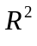and respectively) as well as coefficients of determination for GLS models () incorporating a single autoregressive term.
 |  | OLS |  |  |  | GLS (AR1)
Explanatory Groups (q) | Covariable Groups
site (19) | year + fire/grazing | 0.48 | 0.48 |  | 0.27
year (10) | site + fire/grazing | 0.13 | 0.13 |  | 0.18
fire/grazing (3) | site + year | 0.04 | 0.04 |  | 0.02
site + year | fire/grazing | 0.01 | -0.02 |  | 0.25
site + fire/grazing | year | 0.05 | 0.05 |  | 0.04
year + fire/grazing | site | 0.08 | 0.07 |  | < 0.01
site + year + fire/grazing | NA | -0.01 | -0.02 |  | < 0.01
Total (32) |  | 0.77 | 0.74 |  |  | 0.77

Table 2. The conditional explanatory power of specific variables on species richness estimated with the GLS autoregressive models. The classes site, year, and fire and grazing are as defined in Table 1. Each model incorporated only a single autoregressive term. Cells marked as “--” indicate that their values are identical to cells above. The standardized regression coefficient (β) is also given to indicate the strength and direction of the response of richness, an estimate of variation explained (), and the results of conditional F-tests (approximate tests).
Explanatory Variables | Covariables | β |  | F-ratio | p-value
Groups (q)
site (19) | year + fire and grazing | NA | 0.27 | 11.53 | < 0.001
year (10) | site + fire and grazing | NA | 0.18 | 13.17 | < 0.001
fire and grazing (3) | site + year | NA | 0.02 | 6.40 | < 0.001
Site Specific Variables
log Ca | slope + northness + year + fire and grazing | -0.42 | 0.04 | 25.39 | < 0.001
slope | log Ca+ northness + year + fire and grazing | -0.12 | < 0.01 | 1.88 | 0.172
northness | log Ca + slope + year + fire and grazing | 0.17 | 0.01 | 4.02 | 0.047
Year Specific Variables
summer rain | winter rain + spring rain + site + fire and grazing | -0.19 | 0.03 | 26.65 | < 0.001
winter rain | summer rain + spring rain + site + fire and grazing | 0.15 | 0.02 | 15.47 | < 0.001
spring rain | summer rain + winter rain + site + fire and grazing | 0.14 | 0.01 | 11.43 | 0.001
Fire and grazing variables
years of bison | years since burn + # of burns in 5 years + site + year | 0.46 | 0.01 | 12.00 | < 0.001
years since burn | years of bison + # of burns in 5 years + site + year | -0.14 | < 0.01 | 5.67 | 0.018
# of burns in 5 years | years of bison + years since burn + site + year | -0.15 | < 0.01 | 2.82 | 0.095
Table 3. The results of Monte Carlo randomization tests using the results of pCCA under the reduced model. Each randomization test was conducted with 999 iterations. The groups site, year, and fire and grazing are as defined in Table 1. Cells marked as “--” indicate that their values are identical to cells above.
Explanatory Variable | Covariables | Type of Randomization* | 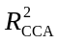 | 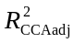 | F-ratio | p-value
Groups (q)
site (19) | year + fire & grazing | random shuffle | 0.50 | 0.46 | 13.471 | 0.001
year (10) | site + fire/grazing | toroidal shift | 0.04 | < 0.01 | 2.248 | 0.001
fire/grazing (3) | site + year | random shuffle | 0.01 | < 0.01 | 2.145 | 0.001
-- | -- | toroidal shift | -- | -- | -- | 0.001
Site Specific Variables
log Ca | slope + northness + year + fire/grazing | random shuffle | 0.13 | 0.12 | 19.735 | 0.001
slope | log Ca+ northness + year + fire/grazing | random shuffle | 0.03 | 0.03 | 8.152 | 0.001
northness | log Ca + slope + year + fire/grazing | random shuffle | 0.02 | 0.01 | 5.219 | 0.001
Fire/Grazing Variables
years of bison | years since burn + # of burns in 5 years + site + year | random shuffle | < 0.01 | < 0.01 | 2.314 | 0.001
-- | -- | toroidal shift | -- | -- | -- | 0.001
years since burn | years of bison + # of burns in 5 years + site + year | random shuffle | < 0.01 | < 0.01 | 2.102 | 0.001
-- | -- | toroidal shift | -- | -- | -- | 0.001
# of burns in 5 years | years of bison + years since burn + site + year | random shuffle | < 0.01 | < 0.01 | 1.616 | 0.001
-- | -- | toroidal shift | -- | -- | -- | 0.021
* random shuffle permutations were constrained to occur within a year, toroidal shifts were constrained within a given a site and preserved the temporal order of samples (see Methods for more explanation)

Figures

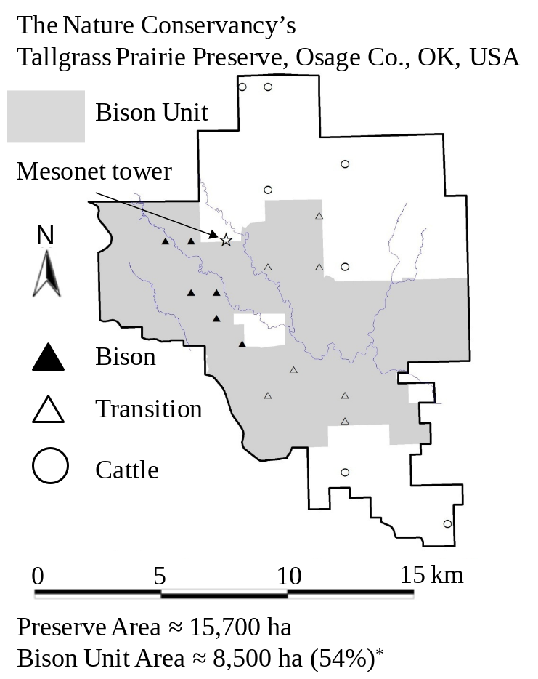
Fig. 1. A map of the Tallgrass Prairie Preserve. The shaded area denotes the bison unit which increased in area during the study period. The Mesonet tower where the climate data was recorded is marked on the map as a star (). The twenty quadrats sampled each year of this study are displayed on the map. The sites that were bison at the beginning of the study (1998) are displayed with filled triangles (▲), those that transitioned during the study from cattle to bison are denoted by unfilled triangles (Δ), and the other cattle grazed samples are denoted by unfilled circles (○). *Area of bison unit is as of May 1, 2008.
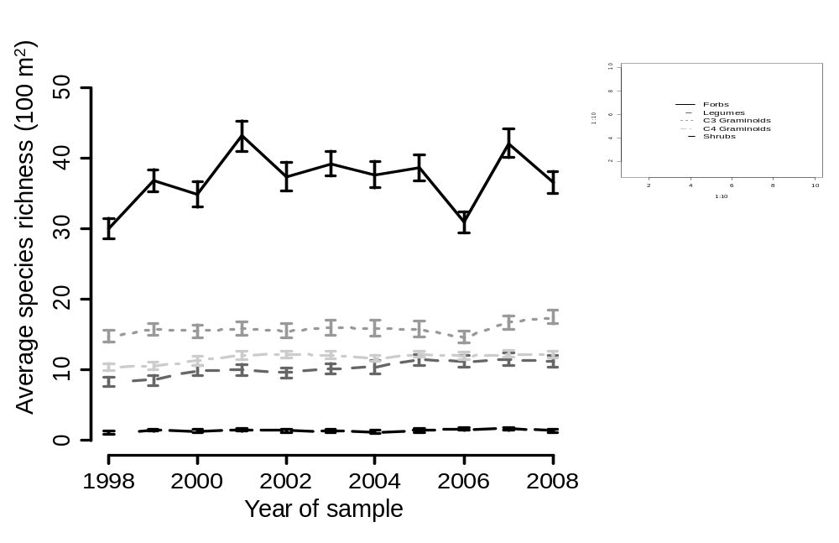
Fig. 2. The average species richness of five functional groups: forbs (that are not legumes), legumes, C3 graminoids (grasses, sedges, and rushes), C4 graminoids, and shrubs (woody plants) over the course of the study. The error bars display ± 1 standard error.
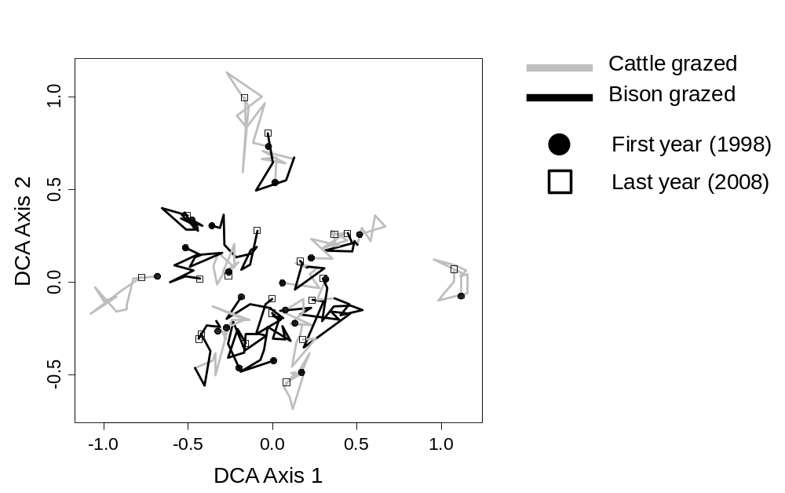
Fig. 3. DCA scatterplot displaying the 20 sites from 1998 to 2008. The eigenvalues were 0.152 and 0.108 for the first and second axis respectively. The time series is indicated by a line segment (—) with joints at each year, a dark black line joins years in which the plot experienced bison grazing and a grey line demarcates years in which the plot experienced cattle grazing. The 1998 samples are indicated by circles (●) and the 2008 samples are indicated by squares (□).
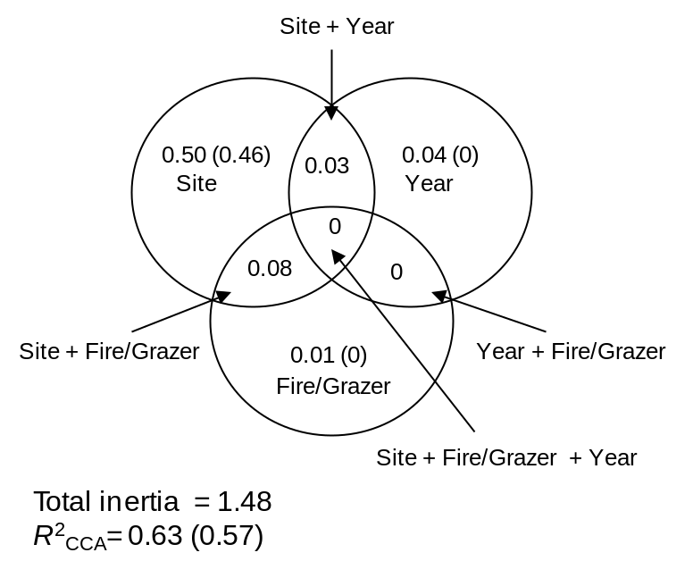
Fig. 4. A Venn diagram displaying the 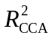 (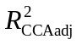) of each fraction resulting from the variation partitioning of species composition using pCCA. The three groups (classes of explanatory variables) were sites, years, and fire and grazing. Note that in this context should not be interpreted as the fraction of explained variance but rather as the fraction of explained inertia. For the shared fractions we only report the unbiased values.
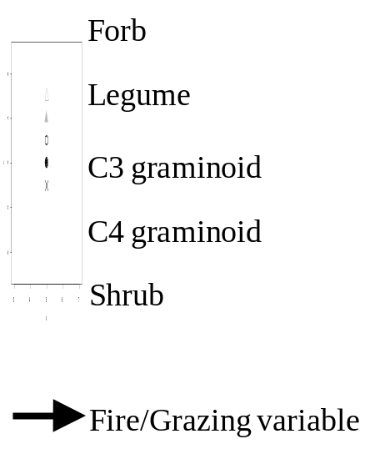
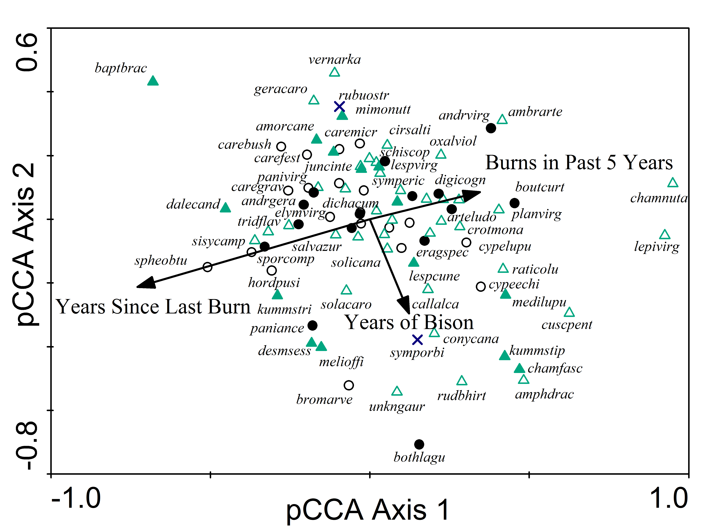
Fig. 5. A pCCA biplot displaying the influence of the fire and grazing variables with the sites and years as covariables. The fire and grazing variables in the model are indicated by black arrows. Only the 90 most abundant species of the 307 total are displayed for clarity. Abbreviations represent the first four letters of the genus and the first four of the letters of the species (see Appendix C). The symbol of each species depends on which functional type it belongs to (see legend).

